## Scotch Crest **YEAR PHYSICS 11 MOTION TEST 1** November 2014

### Total Marks = [50] Time: 50 mins

**NAME:**

**Question 1 (2 marks)**

A farmer walked 745 m West from a gate to repair a fence post. When that job was finished

he turned around and walked 984 m East to repair another part of the fence. Draw and label a vector diagram of his total journey then calculate his resultant displacement.

**Question 2 (2 marks)**

If the total time spent walking by the farmer was 30 minutes, calculate his average velocity and his average speed?

**Question 3 (6 marks)**

The velocity–time graph for a remote control car is shown below.

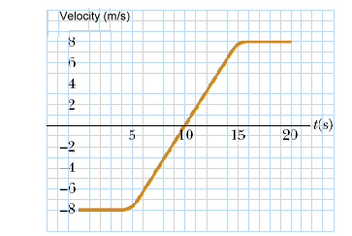

* + 1. What is the velocity and acceleration of the car at t =10s? **[2 marks]**

* + 1. In the space to the right of the graph plot a graph of the acceleration of the car against time. **[2 marks]**
    2. Determine the displacement of the car in the time from t = 5 s to t = 20 s. **[2 marks]**

**Question 4 (4 marks)**

A runway at a small airport is 1220 m long. A light aircraft accelerates at 0.785 m s–2 along this runway, starting at one end and taking off 200 m before reaching the other end. If the aircraft was initially stationary, calculate its speed when it took off.

**Question 5 (12 marks)**  
  
A car of mass 1600 kg left parked on a steep but rough road begins to roll down the hill. After a short while it reaches a constant speed. The road is inclined at 15° to the horizontal. Its speed is sufficiently slow that the air resistance is insignificant and can be ignored.

**a.** Draw in the forces acting on the car when it is parked.   
 **[3 marks]**

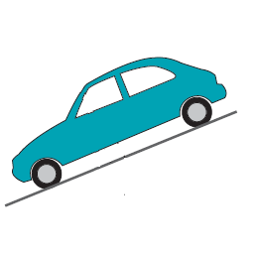

**b.** Determine the component of the car’s weight that acts

parallel to the road **AND** the component that acts perpendicular to the road. **[2 marks]**

**c.** Is there a net force acting on the car when it is parked? Explain. **[1 mark]**

**c.** Is there a net force acting on the car when it is rolling down the hill at constant velocity? Explain.  
 **[2 marks]**

**d.** What is the value of the normal reaction force that the road exerts on the car **AND** the value of road friction when it is rolling down the hill at constant velocity? **[2 marks]  
  
  
  
  
  
e.** As the car comes out of the hill onto the flat road at the base of the hill, what happens to the value of the normal reaction force? Explain. **[2 marks]**

**Question 6 [8 marks]**

Two physics students, James and Jordan, conduct the following experiment from a very high bridge. James drops a 1.5 kg shot-put from a vertical height of 60.0 m while at exactly the same time Jordan throws a 100 g mass with an initial downwards velocity of 10.0 m s–1 from a point 10.0 m above James.

Calculate the time that:

1. the shot-put takes to reach the ground **[2 marks]**
2. the 100 g mass takes to reach the ground. **[2 marks]**
3. At what time will the 100 g mass overtake the shot-put? **[2 marks]**
4. Explain why the acceleration of the shot put and the 100 g mass are the same, even though the shot put is heavier. **[2 marks]**

**Question 7 [6 marks]**

Free-body diagrams are diagrams used to show the relative magnitude and direction of all forces acting upon an object in a given situation. Draw a free body diagram for each of the situations shown below:

1. An egg is free-falling from a nest in a tree. Neglect air resistance. **[2 marks]**
2. A book is at rest on a tabletop.   
    **[2 marks]**
3. As a result of a flat battery, Mr Reberger’s car is towing Mr Robinson’s with a tow rope at a constant velocity. Draw a free body diagram of the forces acting on Mr Robinson’s car

**[2 marks]**

**Question 8 [4 marks]**

The photographs below show a thermometer used to measure the temperature of a solution, and

a ruler measuring the length of a metal strip. For each photograph, record the measurement and

state the uncertainty of the measurement.

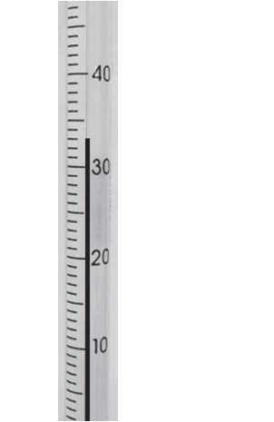SCSA

1. The temperature measured by the thermometer is __________ºC.
2. 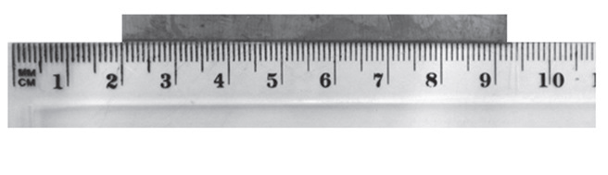The uncertainty is _________________ ºC.

SCSA

**c.** The length of the metal strip measured by the ruler is ____________ cm.

**d.** The uncertainty is ___________________cm.

**Question 9 [6 marks]**

A 70 kg fisherman is quietly fishing in a 40 kg dinghy at rest on a still lake when, suddenly, he is attacked by a swarm of wasps. To escape, he leaps from the boat into the water with a force of 140 N.

1. What is the force acting on the boat? **[1 mark]**
2. With what acceleration will the boat move? **[2 marks]**
3. If the force on the fisherman lasted for 0.5 s, determine the speed attained by both the man and boat.  
    **[3 marks]**